
NAME : VAANI JINDAL
SAP : 500119144
BATCH : 2
SUBJECT : OOPS
EXPERIMENT -10
Java Swing:
1)Write a Java Swing program to create a Login Form using JTextField, JPasswordField, JButton, and JLabel. When the login button is clicked, validate if the username is "admin" and the password is "password".
Code:
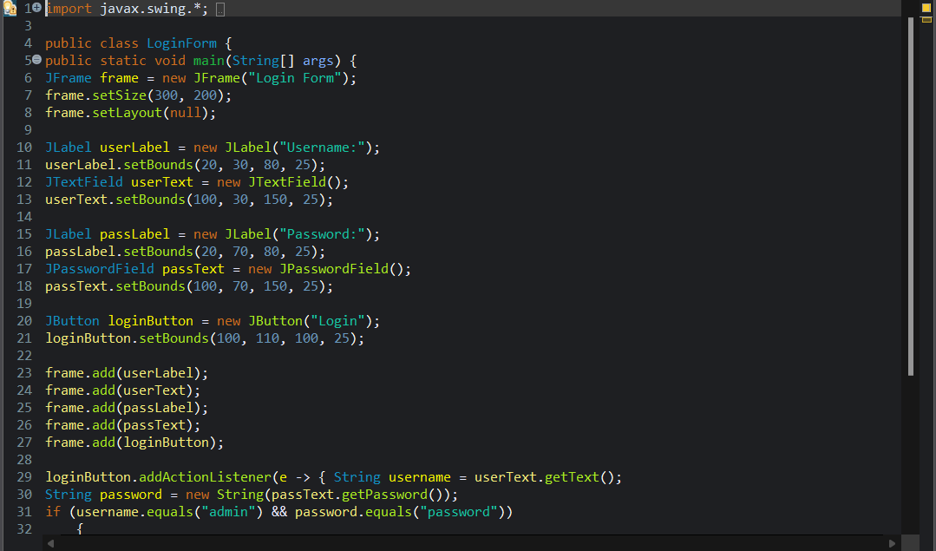
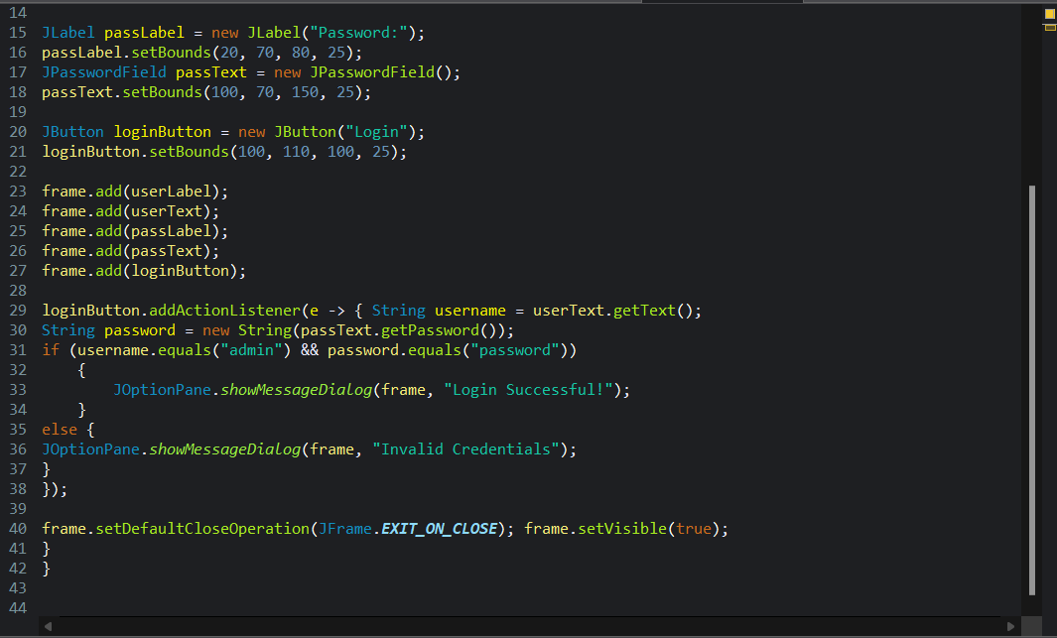
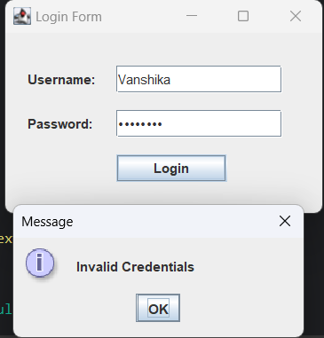
vaani
2) Design a simple calculator using Java Swing with buttons for digits (0-9), addition (+), subtraction (-), multiplication (*), and division (/). Implement event handling for button clicks and display the result in a JTextField.
Code:
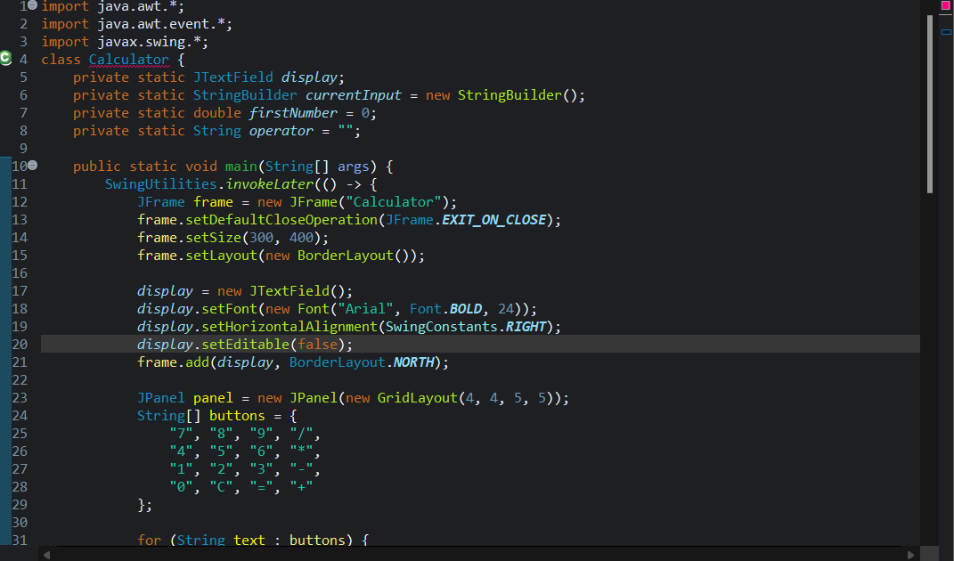
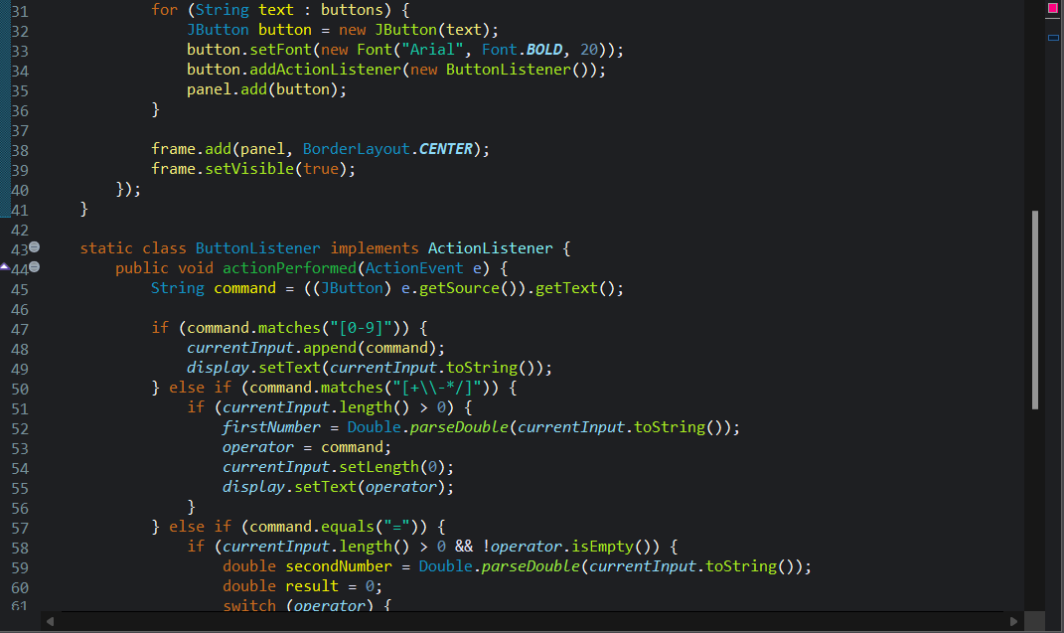
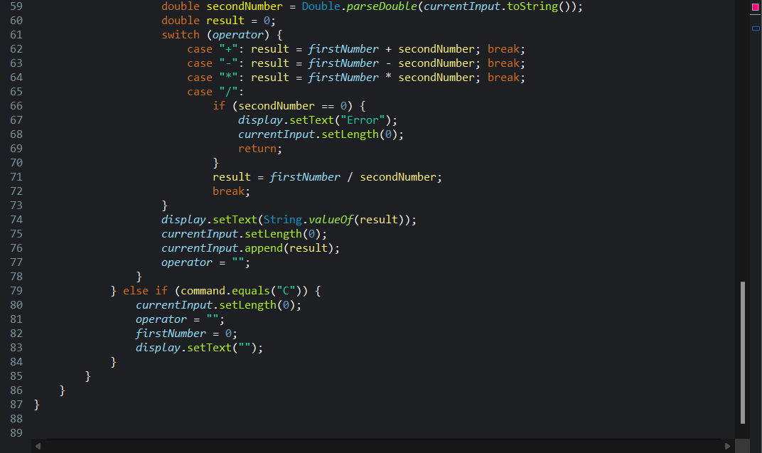
Output:
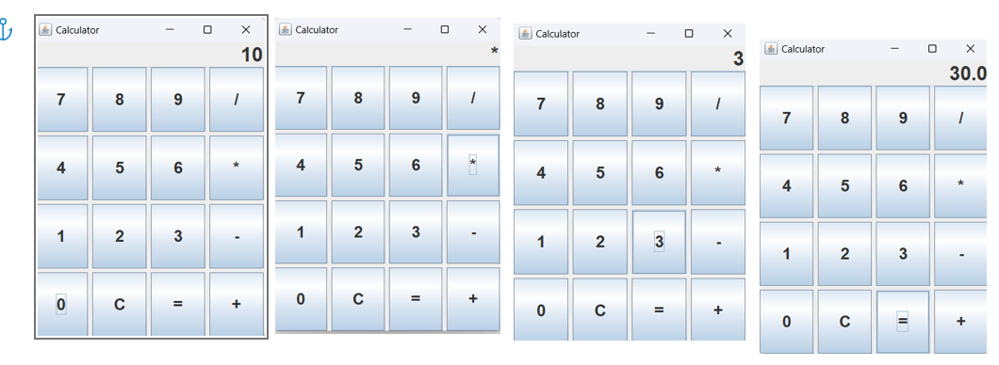
3) Write a Java Swing program to implement a To-Do List using JList. Provide:
a.A JTextField to enter tasks
b.An Add button to add tasks to the list
c.A Remove button to delete selected tasks
code:
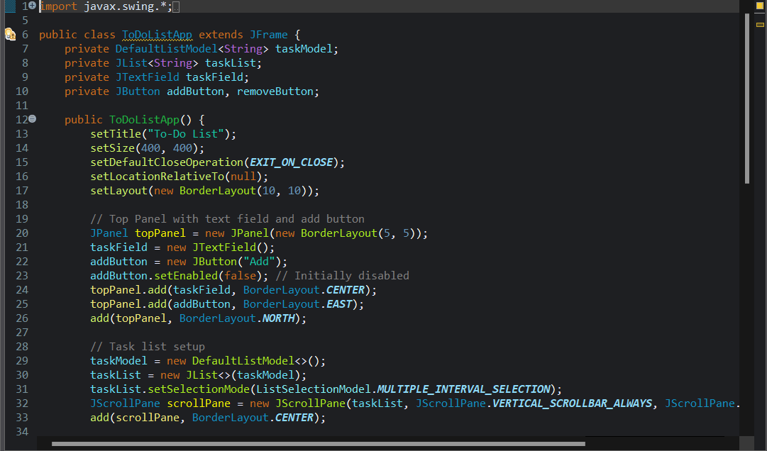
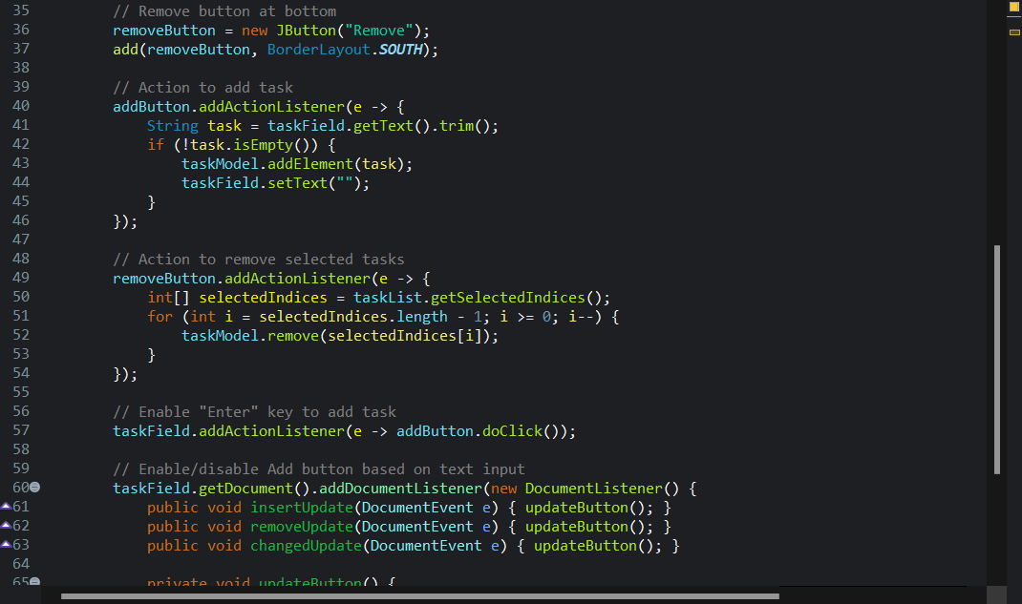
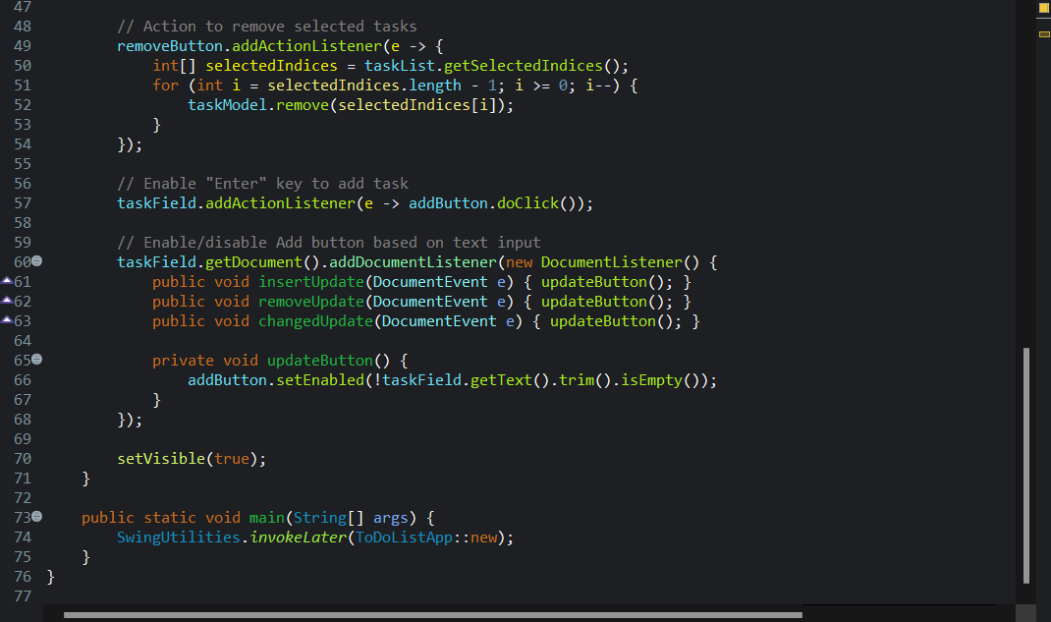
Output:
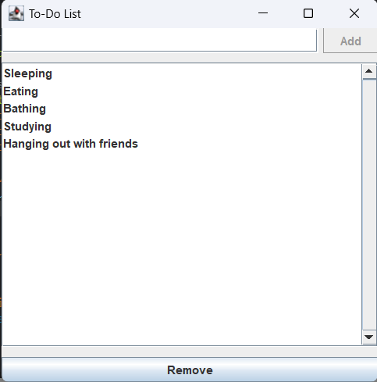
Write a Java Swing program to create a Registration Form that collects user details such as Name, Email, Password, and Confirm Password. Use a combination of JTextField for the name and email inputs, JPasswordField for the password inputs, and a JButton labeled "Register". When the Register button is clicked, validate that none of the fields are empty, that the Password and Confirm Password fields match, and that the email appears valid (for example, containing an “@” symbol). Display a success message on the form if all validations pass; otherwise, show appropriate error messages next to the respective fields
Code:
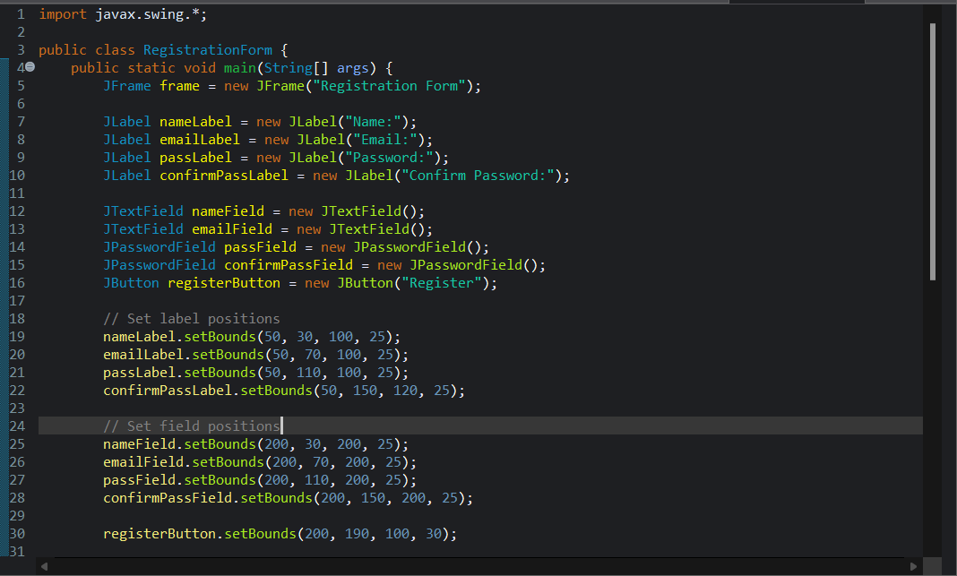
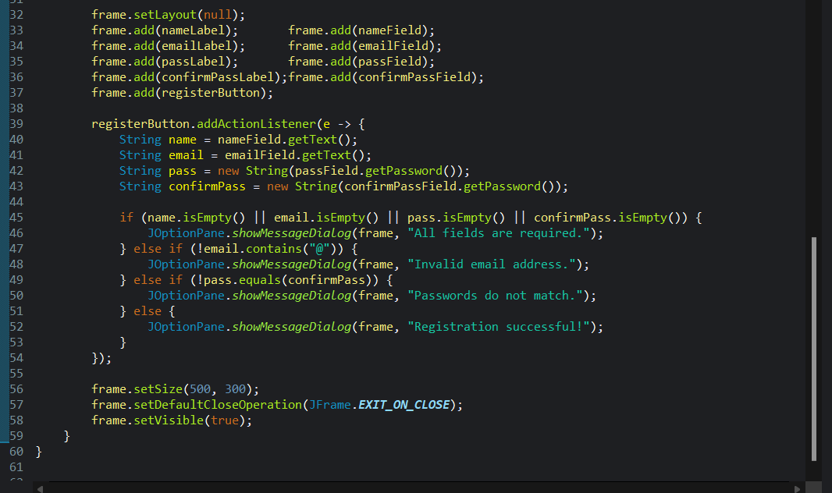

Output:
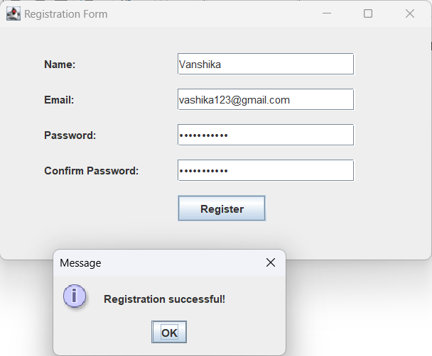
Vaani123@gmail.com
vaani
5) Write a Java Swing program to implement a simple Stopwatch. The GUI should include a JLabel to display the elapsed time (in seconds) and three JButtons labeled "Start", "Stop", and "Reset". Use a Swing Timer to update the JLabel every second while the stopwatch is running. The "Start" button should begin timing, the "Stop" button should pause the timer, and the "Reset" button should set the elapsed time back to zero. Ensure that the GUI updates correctly based on the user’s interactions.
Code:
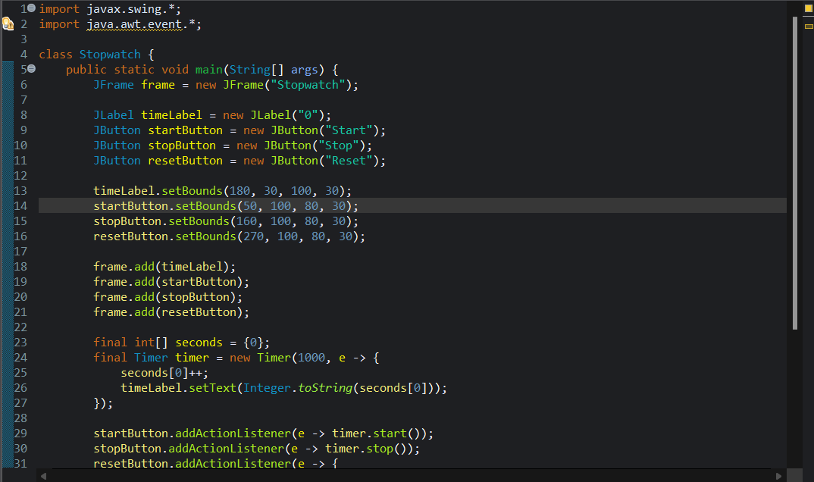
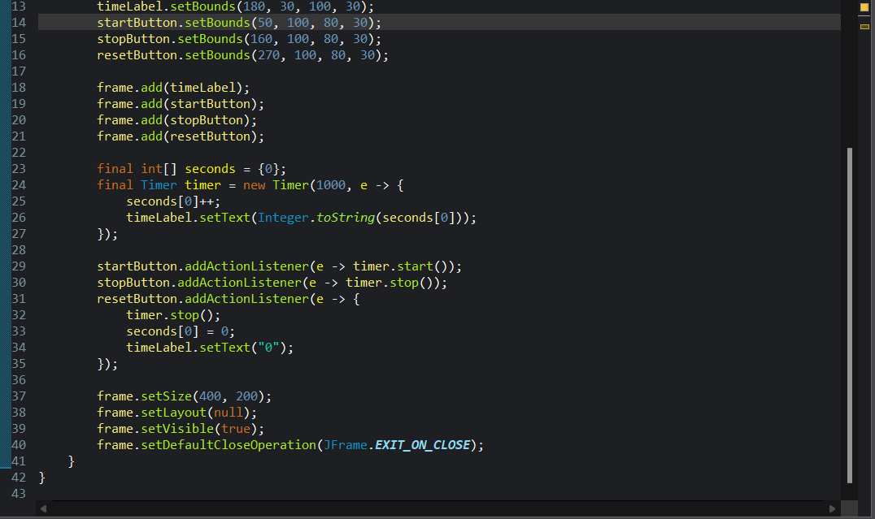

Output:
